2020 Marc Whitten Memorial Music Scholarship

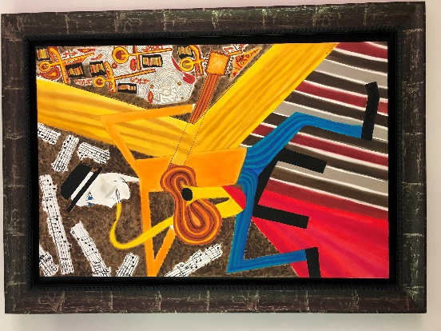
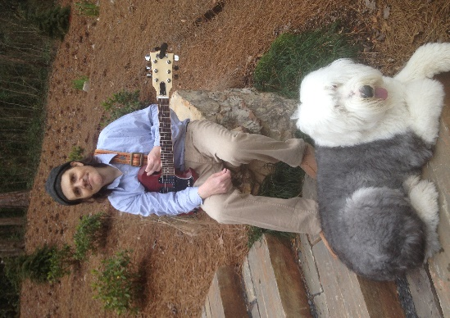

About Marc Whitten:
Marc Whitten had a life-long appreciation for music and art. He began playing the saxophone in middle school, finally settling on the guitar as his instrument of choice. At both Emory University and the University of Georgia, he was a serious student of music theory. Marc suffered from Crohn’s disease from the age of 12 until his death at age 44 in 2018. His passion for music helped him cope with the difficulties of his illness. With a strong interest in music education, Marc took great delight in sharing his love of music (and guitars) with others.

As a tribute to Marc’s love of music and music education, his family and devoted friends created the Marc Whitten Memorial Music Scholarship in 2019. The goals of the scholarship are to help recipients enhance their understanding and appreciation of music, and to honor the short life of Marc Whitten.

Eligibility:
To be eligible for the award a student must be enrolled in a public or private middle school, high school or college or a verifiable home school. The student must meet all of the following criteria:

- Be a resident of Bibb, Jones, Monroe or Houston County, Georgia
- Have a passing grade point average
- Be actively involved in a music program or desire to be
- Submit a letter of request and proposed use for funds in his/her own words

Purposes:
Funds are available for the purchasing of musical instruments, music equipment, for private lessons or for in-depth study such as summer music camps.

Application:
Deadline for the Fall Semester is November 30. Deadline for the Spring Semester is March 31.

Marc Whitten Memorial Music Scholarship
Application
Deadlines November 30 and March 31

Student information:

Name: _____________________________________________________________________________

Home Address: _____________________________________ Email: ___________________________

City:________________ State:_______ Zip:____________ Home Phone: ____________________

School: ___________________________________________ Grade level:___________________

Musical groups you’re involved with: _____________________________________________________

____________________________________________________________________________________

How will you use these scholarship funds?

__________________________________________________________________________________________________

You must attach a letter, written in your own words, telling us what it will mean to you to receive these scholarship funds and how the funds can help you in music. Please be as specific as possible.

Recommending faculty member:

Name: ____________________________________ Faculty position: ______________________________________

School:_________________________________

Mail application form and letter to: OR Email application form and letter to:
Jazz Association of Macon jazzmacon@gmail.com
Attention: Scholarship Committee
PO Box 4192
Macon, GA 31208

Complete application must be submitted by November 30 for Fall or March 31 for Spring.

